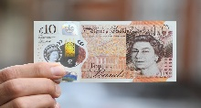
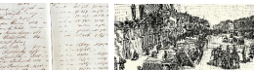
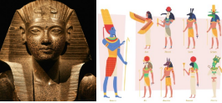
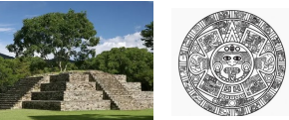
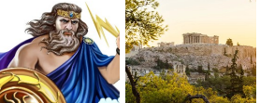
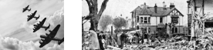
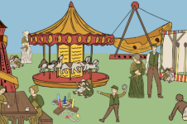
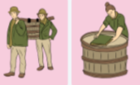
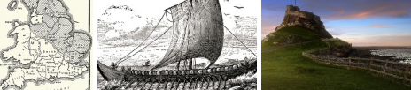
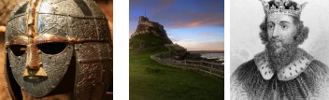
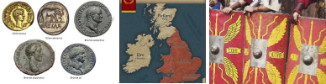
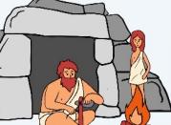
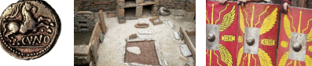
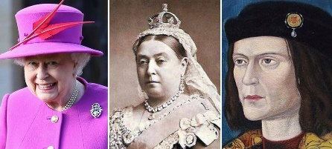
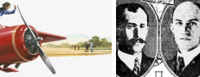
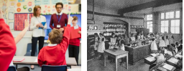
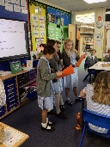
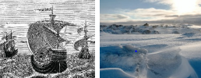
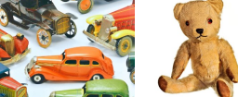

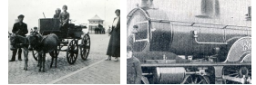
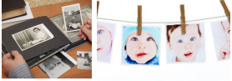

“For with you is the Fountain of life; in your light we see light”
(Psalm 36 vs 9)
Who should feature on the £10 banknote?
What does the census tell us
about our local area?
What did the Ancient Egyptians believe in?
Autumn

Summer
Spring
How did the Maya Civilisation compare to the Anglo Saxons?
What did the Greeks ever do for us?
What was the impact of WW2 on the people of Britain?
Summer
Spring
Autumn
(All with local links)
(All with local links)
How have children’s lives changed?
Were the Vikings raiders,
traders or something else?
How hard was it to invade and settle in Britain
(Anglo-Saxons)
Summer
Spring
Autumn
Why did the Romans invade and settle in Britain?
(with local links)
Would you prefer to have lived in the Stone Age, Iron Age or Bronze Age?
What is a monarch?
How did we learn to fly?
How was school different in the past?
(with local links)
How have explores changed the World?
How have toys changed?
How am I making history?
Autumn
Spring
Adventures Through Time
Peek Into the Past
Year 4
Year 3
Year 2
Summer
Spring 2
Spring 1
Autumn
Summer
Spring
Autumn
Summer
Summer
Spring
Autumn
Year 6
Year 5
Year 1
Reception
History
Learning Journey

